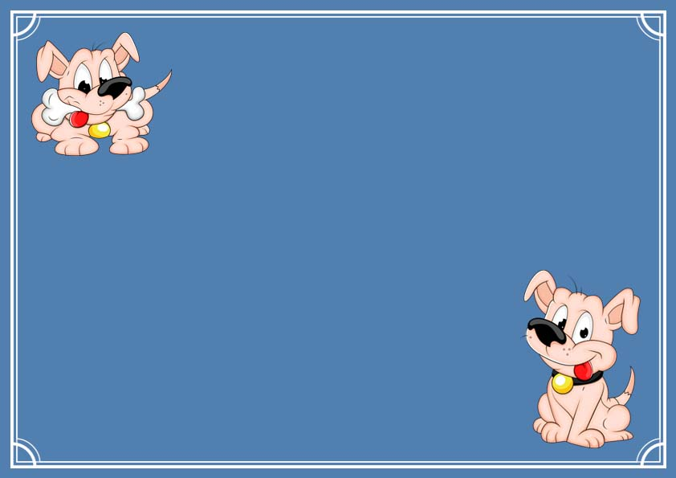

**Certificate of Adoption**

This certifies that

_______________________

Has officially adopted stuffed with love by

_______________________________

And Invited them into their forever home!!!

______________ _____________

Signature Date