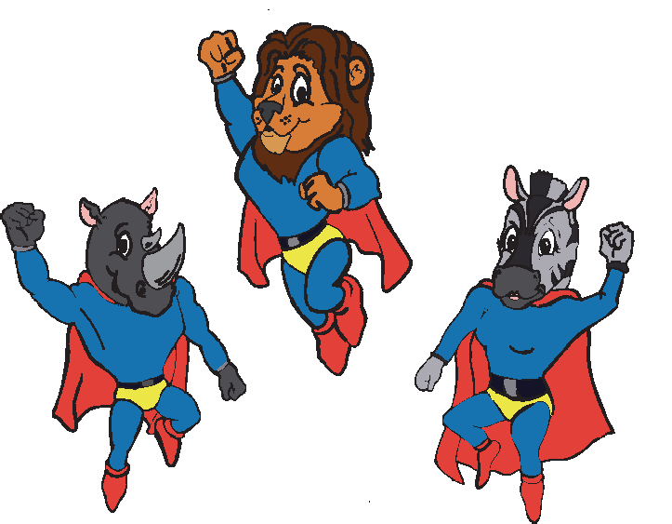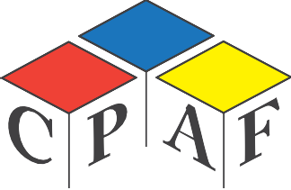Certificate of participation
OBER 2012

This is to certify that
ZUBLARA HASENBERG

represented
GOOD SHEPHERD school

AT THE YOUTH DIALOGUE ON CHILD SAFETY ON THE 26TH OF OCTOBER 2012 HELD AT THE GRAHAMSTOWN PUBLIC LIBRARY

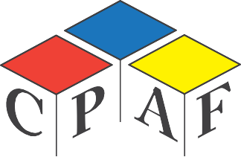Certificate of participation

This is to certify that
ASIPHILE VENA

represented
GOOD SHEPHERD school

AT THE YOUTH DIALOGUE ON CHILD SAFETY ON THE 26TH OF OCTOBER 2012 HELD AT THE GRAHAMSTOWN PUBLIC LIBRARY

Certificate of participation

This is to certify that
INDIBABALE VANDA

represented
ST MARY’S school

AT THE YOUTH DIALOGUE ON CHILD SAFETY ON THE 26TH OF OCTOBER 2012 HELD AT THE GRAHAMSTOWN PUBLIC LIBRARY

Certificate of participation

This is to certify that
THIMNA BOMA

represented
ST MARY’S school

AT THE YOUTH DIALOGUE ON CHILD SAFETY ON THE 26TH OF OCTOBER 2012 HELD AT THE GRAHAMSTOWN PUBLIC LIBRARY

Certificate of participation

This is to certify that
ANDISWA KEPE

represented
N.V CEWU school

AT THE YOUTH DIALOGUE ON CHILD SAFETY ON THE 26TH OF OCTOBER 2012 HELD AT THE GRAHAMSTOWN PUBLIC LIBRARY

Certificate of participation

This is to certify that
NOMONDE SANDI

represented
N.V CEWU school

AT THE YOUTH DIALOGUE ON CHILD SAFETY ON THE 26TH OF OCTOBER 2012 HELD AT THE GRAHAMSTOWN PUBLIC LIBRARY

Certificate of participation

This is to certify that
LINDOKUHLE GOTYI

represented
FIKIZOLO school

AT THE YOUTH DIALOGUE ON CHILD SAFETY ON THE 26TH OF OCTOBER 2012 HELD AT THE GRAHAMSTOWN PUBLIC LIBRARY

Certificate of participation

This is to certify that
BATHINI MAKASI

represented
FIKIZOLO school

AT THE YOUTH DIALOGUE ON CHILD SAFETY ON THE 26TH OF OCTOBER 2012 HELD AT THE GRAHAMSTOWN PUBLIC LIBRARY

Certificate of participation

This is to certify that
ANDILE MENGU

represented
NATHANIEL NYALUZA school

AT THE YOUTH DIALOGUE ON CHILD SAFETY ON THE 26TH OF OCTOBER 2012 HELD AT THE GRAHAMSTOWN PUBLIC LIBRARY

Certificate of participation

This is to certify that
NELISWA MJEJE

represented
NATHANIEL NYALUZA school

AT THE YOUTH DIALOGUE ON CHILD SAFETY ON THE 26TH OF OCTOBER 2012 HELD AT THE GRAHAMSTOWN PUBLIC LIBRARY

Certificate of participation

This is to certify that
Ayabulela Masingili

represented
GEORGE DICKERSON school

AT THE YOUTH DIALOGUE ON CHILD SAFETY ON THE 26TH OF OCTOBER 2012 HELD AT THE GRAHAMSTOWN PUBLIC LIBRARY

Certificate of participation

This is to certify that
AVIWE MAJALI

represented
GEORGE DICKERSON school

AT THE YOUTH DIALOGUE ON CHILD SAFETY ON THE 26TH OF OCTOBER 2012 HELD AT THE GRAHAMSTOWN PUBLIC LIBRARY

Certificate of participation

This is to certify that
SIYASAMKELA MATYA

represented
MARY WATERS school

AT THE YOUTH DIALOGUE ON CHILD SAFETY ON THE 26TH OF OCTOBER 2012 HELD AT THE GRAHAMSTOWN PUBLIC LIBRARY

Certificate of participation

This is to certify that
NAMHLA TUKULU

represented
MARY WATERS school

AT THE YOUTH DIALOGUE ON CHILD SAFETY ON THE 26TH OF OCTOBER 2012 HELD AT THE GRAHAMSTOWN PUBLIC LIBRARY

Certificate of participation

This is to certify that
SANELE GAMA

represented
ANDREW MOYAKE school

AT THE YOUTH DIALOGUE ON CHILD SAFETY ON THE 26TH OF OCTOBER 2012 HELD AT THE GRAHAMSTOWN PUBLIC LIBRARY

Certificate of participation

This is to certify that
ZONKE LINDIWE

represented
ANDREW MOYAKE school

AT THE YOUTH DIALOGUE ON CHILD SAFETY ON THE 26TH OF OCTOBER 2012 HELD AT THE GRAHAMSTOWN PUBLIC LIBRARY

Certificate of participation

This is to certify that
HLUMELO TAFANE

represented
ARCHIE MBOLEKWA school

AT THE YOUTH DIALOGUE ON CHILD SAFETY ON THE 26TH OF OCTOBER 2012 HELD AT THE GRAHAMSTOWN PUBLIC LIBRARY

Certificate of participation

This is to certify that
SELUNATHI SANDI

represented
ARCHIE MBOLEKWA school

AT THE YOUTH DIALOGUE ON CHILD SAFETY ON THE 26TH OF OCTOBER 2012 HELD AT THE GRAHAMSTOWN PUBLIC LIBRARY

Certificate of participation

This is to certify that
JONATHAN VANDER MERWE

represented
P.J OLIVIER school

AT THE YOUTH DIALOGUE ON CHILD SAFETY ON THE 26TH OF OCTOBER 2012 HELD AT THE GRAHAMSTOWN PUBLIC LIBRARY

Certificate of participation

This is to certify that
MARIZEL PRETORIUS

represented
P.J OLIVIER school

AT THE YOUTH DIALOGUE ON CHILD SAFETY ON THE 26TH OF OCTOBER 2012 HELD AT THE GRAHAMSTOWN PUBLIC LIBRARY

Certificate of participation

This is to certify that
ZUKISWA NKAYI

represented
AMASANGO CAREER school

AT THE YOUTH DIALOGUE ON CHILD SAFETY ON THE 26TH OF OCTOBER 2012 HELD AT THE GRAHAMSTOWN PUBLIC LIBRARY

Certificate of participation

This is to certify that
NKOSINATHI SODODO

represented
AMASANGO CAREER school

AT THE YOUTH DIALOGUE ON CHILD SAFETY ON THE 26TH OF OCTOBER 2012 HELD AT THE GRAHAMSTOWN PUBLIC LIBRARY

Certificate of participation

This is to certify that
ENRICO FILLIS

represented
KUYASA SP SCHOOL school

AT THE YOUTH DIALOGUE ON CHILD SAFETY ON THE 26TH OF OCTOBER 2012 HELD AT THE GRAHAMSTOWN PUBLIC LIBRARY

Certificate of participation

This is to certify that
LEA-RANNE DAVIES

represented
KUYASA SP SCHOOL school

AT THE YOUTH DIALOGUE ON CHILD SAFETY ON THE 26TH OF OCTOBER 2012 HELD AT THE GRAHAMSTOWN PUBLIC LIBRARY

