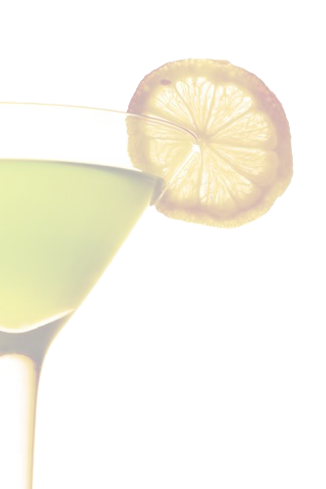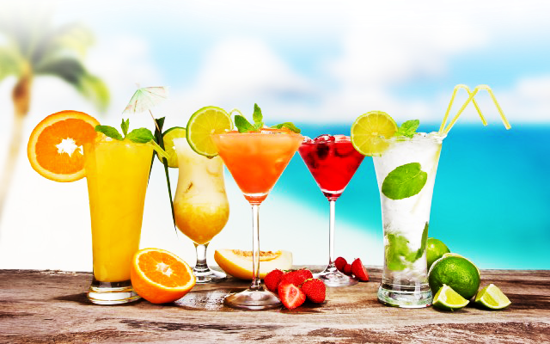

Cocktails

***Cocktail Menu***

Pimms Cup

Pimm’s No. 1, Fresh Squeezed Lemon, Mint, English Cucumber,

Ginger Ale, Square One Organic Cucumber Infused Vodka

Old Fashioned 9

Bulleit Bourbon, Raw Sugar, Luxardo Maraschino Cherries Soda, Orange

O‘Henry 10

Buffalo Trace Bourbon, Benedictine Liqeur, Fever Tree Ginger Beer

Hemingway 9

Aged White Rum, Fresh Lime 6” Grapefruit Juice, Maraschino Liqeur Lucardo Maraschino Cherries

Bijou 10

Boodles Gin, Chartreuse, Carpano Antica Sweet Vermouth Orange Bitters

Silver Laminable 8

Blanco Tequila, Fresh Squeezes Lemon, Agave Nectar, Sugar Rim

Southside 8

Skyy Vodka, Fresh Lemon 6” Lime Juice, Angostura Bitters

Triple Sec, Fresh Mint

Ward Eight 9

Rye Whiskey, Fresh Lemon 8 Orange Juice, House made Grenacline

Luxardo Maraschino Cherries