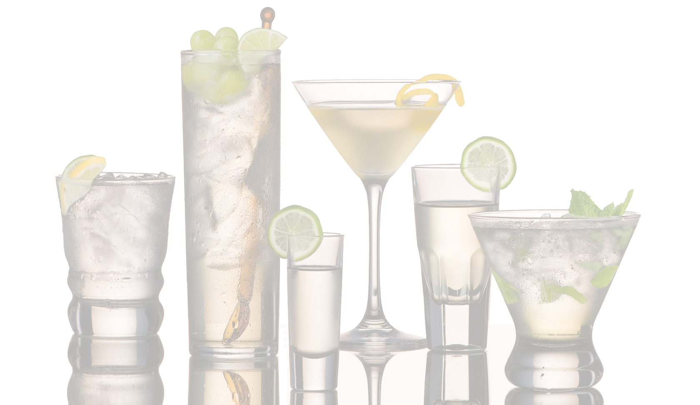

Hot Drinks

**Small Medium Large**

Cafe Latte expresso with steamed milk 2.75 3.25 3.75

Vanilla Latte 2.75 3.25 3.75

Caramel Latte 2.75 3.25 3.75

Mocha 2.75 3.25 3.75

Red Chile Mocha 2.75 3.25 3.75

Raspberry Mocha 2.75 3.25 3.75

Mexican Mocha 2.75 3.25 3.75

Mocha Bianca 2.75 3.25 3.75

Breve 2.75 3.25 3.75

Cappuccino 2.75 3.25 3.75

Expresso 2.75 3.25 3.75

Americano/Brewed Coffee 2.75 3.25 3.75

Steamer 2.75 3.25 3.75

Hot Chocolate 2.75 3.25 3.75

Chai Latte 2.75 3.25 3.75

London Fog 2.75 3.25 3.75

Hot Tea 2.75 3.25 3.75

Cold Drinks

Cafe Latte 3.25 3.75

Vanilla Latte 3.25 3.75

Caramel Latte 3.25 3.75

Mocha 3.25 3.75

Raspberry Mocha 3.25 3.75

Italian Soda 3.25 3.75

Cremosa 3.25 3.75

Iced Chai 3.25 3.75

Iced Coffee 3.25 3.75

Iced Tea 3.25 3.75

Blended Drinks

Frozen Fruits Smoothie 3.25 3.75

Vanilla Creme Freeze 3.25 3.75

Ja’ Mocha Freeze 3.25 3.75

***Drinks Menu***