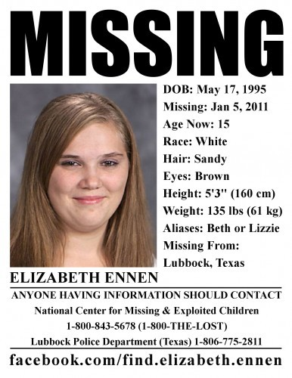

Missing Person Poster

ADDRESS LINE 1 ADDRESS LINE 2

STREET NO, CITY STATE ZIP

COUNTRY NAME

**PERSON'S NAME**

Last seen Saturday Noon

_ Day of _ Month of 20_

PLEASE CONTACT ON CALLING NUMBERS

111-111-01234 OR 555-555-55555

$ 5,000 Reward

Missing