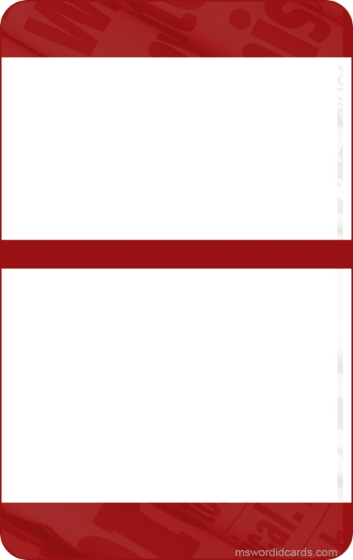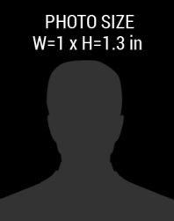barcode.png

+1 341-654-7890

December 2018

Phone Number:

Date of Birth:

01-08-1985

Expiry Date:

January 2017

Member Since:

+1 341 657 7890

DESIGNATION

LAST NAME

**FIRST**

ASSOCIATION

NATIONAL PRESS

123 Anywhere Street, City

PRESS