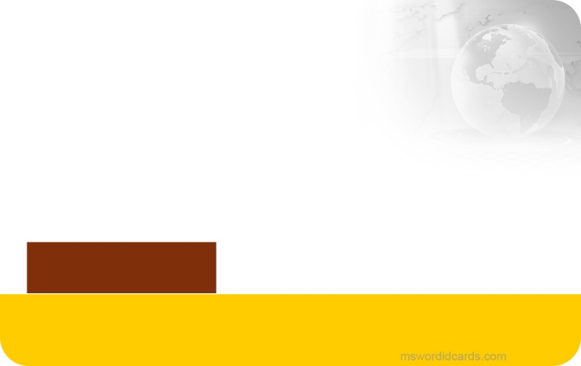barcode.png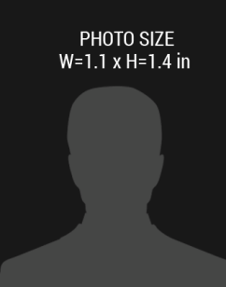

December 2018

01-08-1985

+1 241-654-7890

January 2017

**NATIONAL PRESS ASSOCIATION**

PRESS

Expiry Date:

Date of Birth:

Phone Number:

**First,** Last Name

Member Since:

Designation

**NEWS MEDIA**